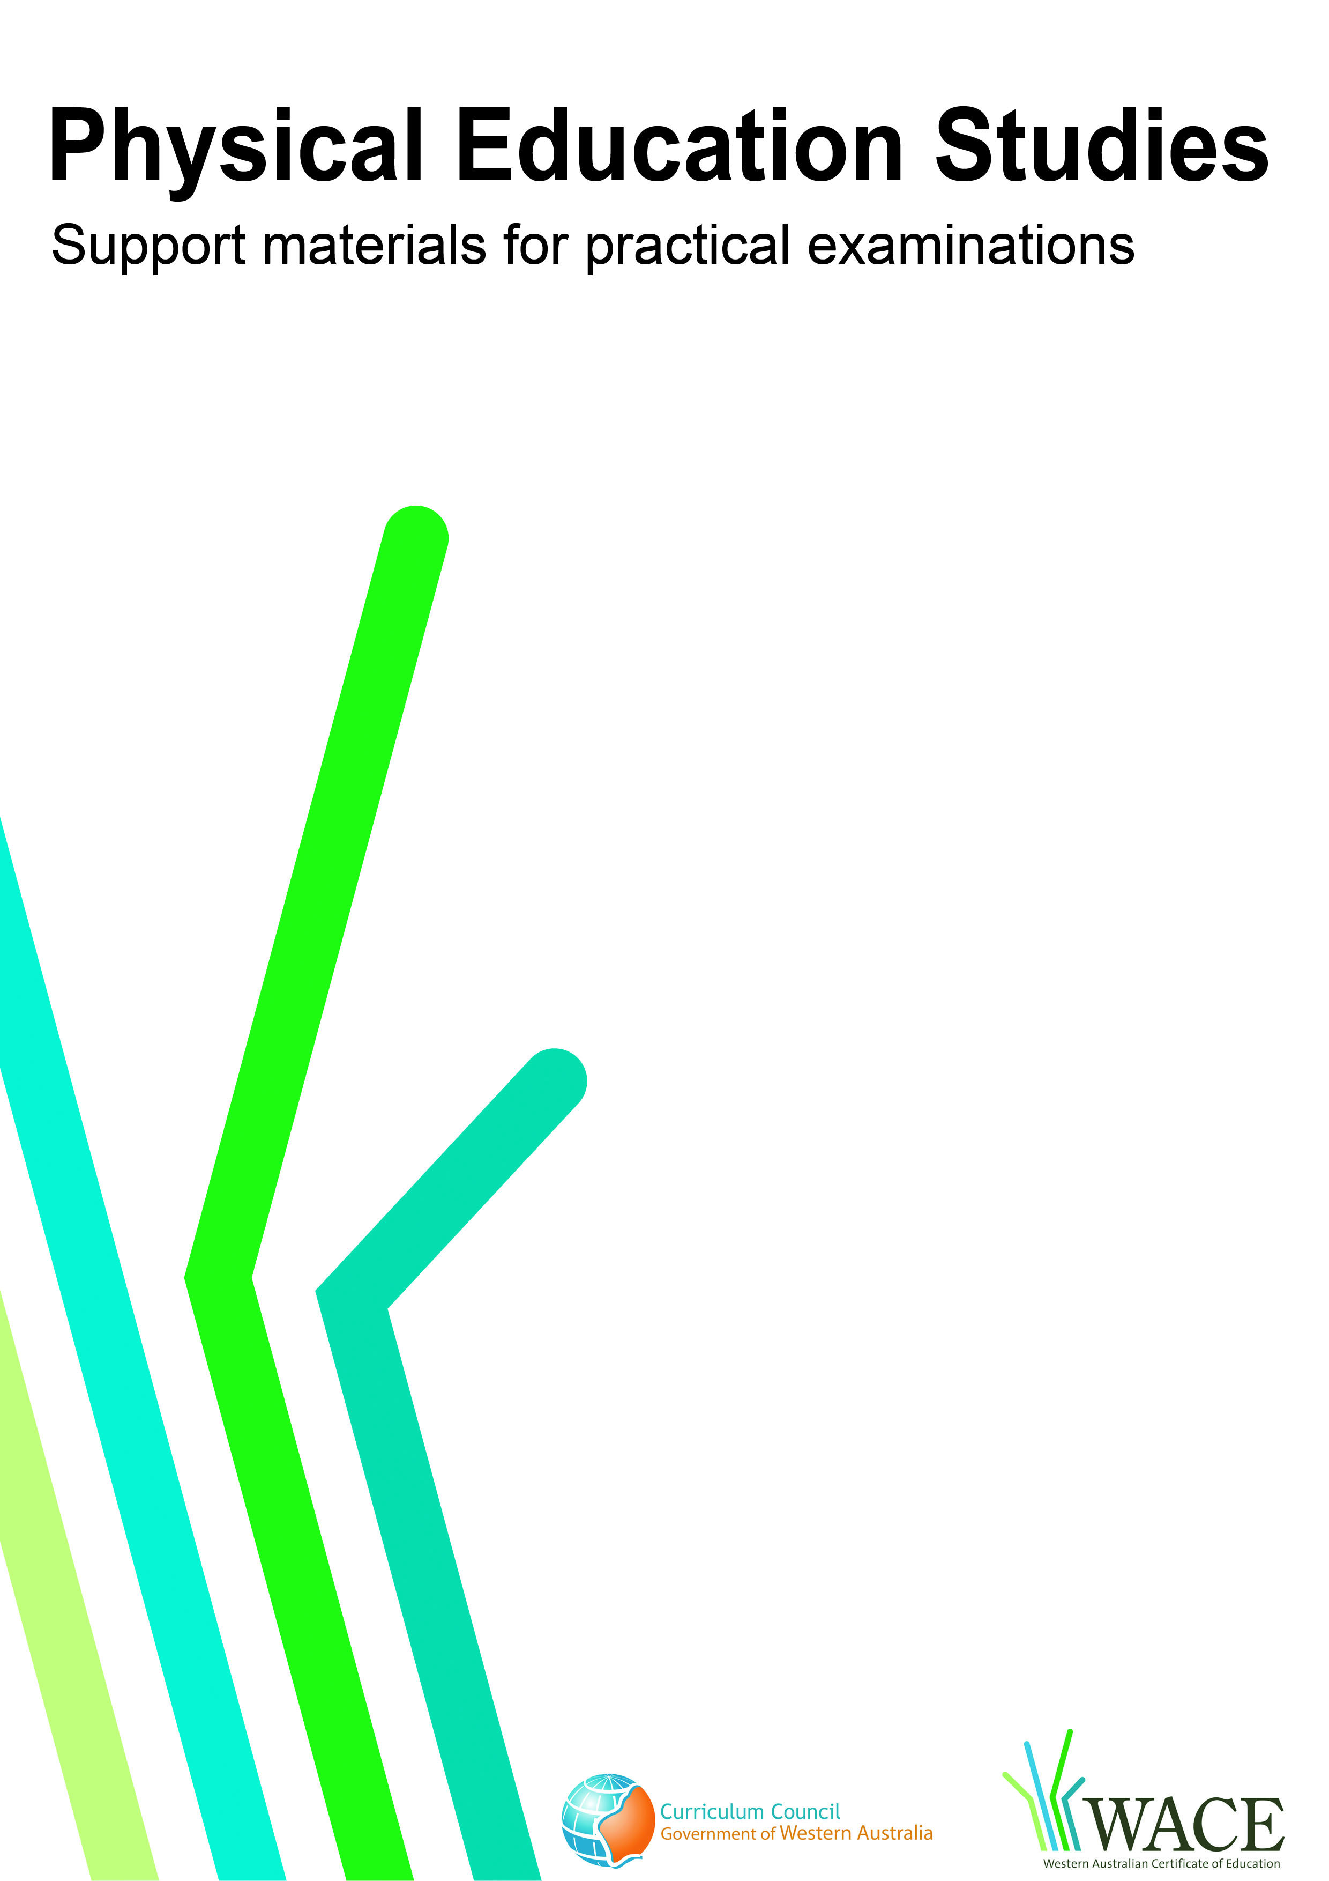

AFL

© Curriculum Council, 2011
This document—apart from any third party copyright material contained in it—may be freely copied, or communicated on an intranet, for non-commercial purposes by educational institutions, provided that it is not changed in any way and that the Curriculum Council is acknowledged as the copyright owner.
Copying or communication for any other purpose can be done only within the terms of the Copyright Act or by permission of the Curriculum Council.
Copying or communication of any third party copyright material contained in this document can be done only within the terms of the Copyright Act or by permission of the copyright owners.
Version 5
Introduction
The purpose of these materials is to support teachers and candidates in preparation for the Physical Education Studies practical examination.

Skills set for AFL
These materials outline the examinable skills set for AFL. Five (5) of the skills, selected by the examination panel, will be examined and these will be communicated to the candidates at the commencement of the examination.

Observation points
Observation points are provided for each skill in the skills set. They are provided for the purpose of teaching and coaching and are designed to assist examination candidates in their personal skill development.

Examination drills
The examination will contain a number of drills through which the selected skills will be assessed. These materials outline a number of drills indicative of the types of drills in which the candidates will participate during the examination and may form part of a teaching program.

Tactical framework
In the conditioned performance section of the examination, candidates will participate in a modified competitive situation, which will be based on some of the tactical problems in AFL. The tactical problems for the examination are outlined in the tactical framework and will be selected by the examination panel. The skills that provide the basis for the solutions to these tactical problems are also included in the framework.

In the conditioned performance section of the AFL examination, students will be assessed on the execution of skills, use of space, positioning and decision making that effectively solve the tactical problems presented by the modified competitive situation.

CONTENTS | PAGE NUMBER
AFL skills set | 4
Skills set and observation points | 5
AFL drills | 11
Drill descriptions | 12
Tactical framework | 30

Skill number | Name of skill | Page number
1 | Running drop punt | 6
2 | Handball | 6
3 | Bounce | 6
4 | Chest mark | 7
5 | Picking up the ball | 7
6 | Kick for goal (running drop punt) | 7
7 | Chest height hand mark | 8
8 | Shepherd | 8
9 | Overhead mark | 8
10 | Block | 9
11 | Set shot for goal | 9
12 | Tackle | 10
13 | Spoil | 10

1. RUNNING DROP PUNT
Preparation |  | Execution | Completion
- Both hands hold the ball on either side with fingers spread  - The nose of the ball is positioned over the kicking foot  - Balance is maintained while transferring body weight to non-kicking foot |  | - Kicking leg swings back with flexion of the knee and extension of the hip  - Kicking leg swings from behind the ball to extend through to execute the kick  - Ball speed and height are achieved by utilising full range of motion of the kicking leg  - Ball is guided with the same hand as kicking foot  - The top of the foot makes contact with the ball at bottom rear of the ball while pointing kicking foot in direction of target  - Non-kicking leg provides a strong base  - Eyes focus on the ball and body comes up onto toe of the non-kicking foot at impact | - Follow through with chest square to the target  - Follow through is in the direction of the kick  - Ball travels end-over-end with back spin, to intended target
2. HANDBALL
Preparation |  | Execution | Completion
- Ball is held in non-hitting hand extended in front of the body  - Hitting hand is clenched with thumb on the outside of the fist  - Body is balanced with weight on the back leg  - Hitting arm is flexed at the elbow and hand swings behind the body |  | - Weight is transferred onto the support leg  - Hitting arm swings forward contacting the ball slightly prior to full extension of the elbow  - Velocity and angle of handpass is appropriate to distance required | - Arm follows through in the direction of intended target  - Ball travels end-over-end with back spin, to intended target
3. BOUNCE
Preparation | Execution |  | Completion
- Ball is carried in two hands with fingers spread, elbows flexed and close to the upper torso  - Movement begins while opposite foot is forward | - Elbow extends to push the ball towards the ground  - Bounce of the ball is at an appropriate angle and distance to enable ball to return to the hands  - Ball is pushed from the chest and released at approximately hip height |  | - Ball comes back up to hands at hip height  - Ball is caught in both hands out in front of the body for quick release, if needed

4. CHEST MARK
Preparation | Execution | Completion
- Body is positioned in line with the flight of the ball  - Eyes follow flight path of the ball  - Body moves towards the ball | - Arms are brought forward with elbows flexed  - Elbows are flexed next to torso  - Torso flexion absorbs the force  - Knees are flexed as the ball is marked  - Jump into the ball depending on the height that the chest mark is taken | - Ball is taken cleanly in one grab to prepare for next phase
5. PICKING UP THE BALL
Preparation | Execution | Completion
- Body position is lowered by flexing hips and knees  - Hands and arms prepare for pick up  - Foot is positioned on the outside of and near the ball  - Balance and speed are maintained throughout the movement  - Eyes focus on the ball | - Feet are positioned to ensure a wide base of support  - Weight is placed on the front foot just before pick up  - Hands come together to secure the ball  - Ball picked up in two hands | - Ball is taken cleanly in one grab  - Extension through the hips to get back to upright position  - Pace is adjusted according to ball direction and game conditions
6. KICK FOR GOAL (RUNNING DROP PUNT)
Preparation | Execution | Completion
- Eyes focus on ball  - Both hands hold the ball on either side with fingers spread  - The nose of the ball is positioned over the kicking foot  - Balance is maintained while transferring body weight to non-kicking foot  - Target is selected behind the goal | - Kicking leg swings back with flexion of the knee and extension of the hip  - Kicking leg swings from behind the ball to extend through to execute the kick  - Ball speed and height are achieved by utilising full range of motion of the kicking leg  - Ball is guided with the same hand as kicking foot  - The top of the foot makes contact with the ball at bottom rear of the ball while pointing kicking foot in direction of the target  - Non-kicking leg provides a strong base  - Eyes focus on the ball and body comes up onto toe of the non-kicking foot at impact | - Chest is positioned square to the target  - Follow through in the direction of the kick  - Ball travels end-over-end with back spin, through goal posts

7. CHEST HEIGHT HAND MARK
Preparation | Execution | Completion
- Body position adjusted to be in line with the flight of the ball  - Eyes follow flight path of the ball.  - Body moves towards the ball | - Shoulders and elbows extend so that hands move forward ahead of the body  - Fingers spread and elbows flexed  - Ball is marked in front maintaining elbow flexion and along the midline of the body. | - Ball taken cleanly into hands in one grab to prepare for next phase
8. SHEPHERD
Preparation | Execution | Completion
- Eyes track opposing players  - Position established to intercept opponent | - Arms begin to extend in preparation for contact  - Knees and hips are flexed in preparation to absorb contact  - Arms and knees are wide below shoulder level  - Body is maintained in a low, balanced position  - Contact and movement are maintained along opponent’s path | - Opponent is kept away from team-mate  - Team-mate followed to prepare for next phase
9. OVERHEAD MARK
Preparation | Execution | Completion
- Body is positioned in line with the flight of the ball  - Eyes follow flight path of the ball  - Take off position at appropriate distance to intercept the flight of the ball  - Hips and knees are flexed | - Take off using one leg  - Jump is into path of the ball  - Lead knee maintains flexed position  - Fingers are spread and elbows flexed  - Ball is marked in front maintaining elbow flexion along the midline of the body | - Elbows and lower arms are flexed to guide ball into control  - Ball is cleanly marked  - Landing on two feet

10. BLOCK
Preparation | Execution | Completion
- Position established to intercept opponent  - Eyes track opposing players  - Arms are kept in close to the body | - Knees and hips are flexed in preparation to absorb contact  - Body is maintained in a low, balanced position  - Body weight drives into opponent through flexed legs | - Opponent is kept away from team-mate  - Team-mate is followed to prepare for next phase
11. SET SHOT FOR GOAL
Preparation | Execution | Completion
- Both hands hold the ball on either side with fingers spread  - The nose of the ball is positioned over the kicking foot  - Balance is maintained while transferring body weight to non-kicking foot  - Target is selected behind the goal  - Movement begins at an appropriate distance behind the mark for approach routine  - Rhythmical approach is used consisting of walking and running strides | - Kicking leg swings back with flexion of the knee and extension of the hip  - Kicking leg swings from behind the ball to fully extend through to execute the kick  - Ball speed and height are achieved by utilising full range of motion of the kicking leg  - Ball is guided with the same hand as kicking foot  - The top of the foot makes contact with the ball at bottom rear of the ball while pointing kicking foot in direction of goal  - Non-kicking leg provides a strong base  - Eyes focus on the ball and body comes up onto toe of the non-kicking foot at impact | - Chest is positioned square to the target  - Follow through in the direction of the kick  - Ball travels end-over-end with back spin, to score goal

12. TACKLE
Preparation | Execution | Completion
- Eyes track opposing players  - Position established to intercept opponent  - Arms kept in close to the body  - Knees and hips are flexed in preparation to absorb contact  - Stride rate is increased to produce acceleration towards the target | - Flexion of knees and hips is maintained  - Body weight drives into opponent through flexed legs  - Arms extend to wrap opponent’s arms and body between their shoulders and knees | - Opponent is unable to hand the ball off resulting in ball-up or opponent releases ball which is gathered by the tackler or a team-mate
13. SPOIL
Preparation | Execution | Completion
- Body is positioned in line of flight of the ball  - Eyes follow flight path of the ball  - Take off position at appropriate distance from flight of the ball  - Hips and knees are flexed | - Take off is executed from one leg  - Jump in a direction to intercept the flight of the ball  - Flexed position of lead knee is maintained  - One arm is used with clenched fist and extending through shoulders and elbows  - Ball is contacted with adequate force to stop the player from taking the mark | - Opponent fails to mark the ball

Drill number |  | Page number
1 | Running drop punt | 12
2 | Handball | 13
3 | Bounce | 14
4 | Chest mark | 15
5 | Chest height hand mark | 16
6 | Picking up the ball | 17
7 | Kick for goal (running drop punt) | 18
8 | Set shot for goal | 19
9 | Shepherd | 20
10 | Block | 21
11 | Overhead mark | 22
12 | Tackle | 23
13 | Spoiling | 24
14 | Running drop punt, handball, bounce, marking (3 types) | 25
15 | Running drop punt, marking (3 types), handballing, bouncing | 26
16 | Handball, shepherd, picking up the ball, chest height hand mark | 27
17 | Marking (3 types), spoiling, picking the ball up, handball, running drop punt, blocking | 28
18 | Handball, running kicking for goal, shepherd, tackle | 29

These drills are indicative of the types of drills in which the candidates will participate during the examination and may form part of a teaching program.

Drill 1: Running drop punt

X
30m
X
2m
2m

Key | X = player  O = feeder  = marker  → = player movement  ----- = ball movement

Drill description
- Player kicks to a stationary player inside a two-metre square, 30 metres away.
- Player must be running at a moderate pace for a successful completion of the running drop punt.
- The stationary player must get two hands to the ball whilst standing in the square.

Variations
- Stationary opponent is positioned 15m from the square. Running drop punt is kicked over this opponent to the team-mate in the square.
- Same as variation one, however opponent runs at the kicker.

Drill 2: Handball

X
X
1m

5m

Key | X = player  O = feeder  = marker  → = player movement  ----- = ball movement

Drill description
- Player running at a moderate pace and handballs to a stationary player in a one-metre square at a 45 degree angle to the handballer.
- Player moves off to support.

Variations
- Static opponent two metres away from the target.
- Opponent comes at the handballer.

Drill 3: Bounce

X
15m
15m

Key | X = player  O = feeder  = marker  → = player movement  ----- = ball movement

Drill description
- The player runs 30 metres and at the midway point will execute a bounce.

Variations
- Moderate pace.
- At maximum speed.

Drill 4: Chest mark

X₃
X₄
X₂
X₁
X₆
X₅
O
Mark the ball

Key | X = player  O = feeder  = marker  → = player movement  ----- = ball movement

Drill description
Groups of five or six
- X₁ runs forward to receive a chest mark off the feeder’s kick.
- Player kicks or handballs the ball back to the feeder and joins the back of the line.
- X₂ moves forward and repeats the above drill.
- Continue through the line.

Variations
- Ball is kicked straight at X₁ at chest height.
- Ball is kicked away so X₁ must turn and run back to chest mark.
- X₁ runs at an angle to the chest mark.
- Ball is kicked low to X₁.

Drill 5: Chest height hand mark

X₃
X₄
X₂
X₁
X₆
X₅
O
Hand mark the ball

Key | X = player  O = feeder  = marker  → = player movement  ----- = ball movement

Drill description
Groups of five or six
- X₁ runs forward to receive a chest-height hand mark off the feeder’s kick.
- Player kicks or handballs the ball back to the feeder and joins the back of the line.
- X₂ moves forward and repeats the above drill.
- Continue through the line.

Variations
- Ball is kicked straight at X₁.
- Ball is kicked on an angle to X₁.
- Ball is kicked at X₁ with X₂ putting pressure on from behind.

Drill 6: Picking up the ball

X₃
X₄
X₂
X₁
X₆
X₅
O
Pick up the ball

Key | X = player  O = feeder  = marker  → = player movement  ----- = ball movement

Drill description
Groups of five or six
- Feeder rolls the ball flat towards X₁.
- X₁ runs forward to receive the ball.
- Player kicks or handballs the ball back to the feeder and joins the back of the line.
- X₂ moves forward and repeats the above drill.
- Continue through the line.

Variations
- Ball is stationary.
- Ball is rolling towards X₁.
- Ball is rolling away from X₁.
- Repeat variation two and three with an opponent applying pressure.

Drill 7: Kick for goal (running drop punt)

X₂

X₃
X₁
30 m

Key | X = player  O = feeder  = marker  → = player movement  ----- = ball movement

Drill description
- X₁ kicks from the first marker 30m to the goal. In variations three and four below, X₂ is the first defender.
- After the kick has been made, X₁ becomes the defender and X₂ goes to the back of the line and X₃ moves forward to kick.
- Five attempts at a moderate pace with two shots at goal on a 45 degree angle on either side and one directly in front.

Variations
- Moderate pace.
- Running at faster pace.
- Kicking over a stationary player.
- Kicking over a moving player.

Drill 8: Set shot for goal

X₂

X₃
X₁
30 m

Key | X = player  O = feeder  = marker  → = player movement  ----- = ball movement

Drill description
- X₁ kicks from the first marker 30m to the goal. X₂ stands on the mark, defending the kick.
- After the kick has been made, X₁ becomes the defender and X₂ goes to the back of the line and X₃ moves forward to kick.
- Five attempts with two shots on goal on a 45° angle on either side and one directly in front.

Variations
- Kick is taken 15° from the boundary either side at 30 metres.

Drill 9: Shepherd

X₁
X₂
X₃

Key | X = player  O = feeder  = marker  → = player movement  ----- = ball movement

Drill description
- There are three players; one with a football (X₁), one shepherd (X₂) and one tries to tackle the player with the football (X₃).
- For a period of five seconds the shepherder must keep the opponent away from the ball carrier and then progress on to support.

Drill 10: Block
20m

X₁

20m

X₃

2m
X₂

Key | X = player  O = feeder  = marker  → = player movement  ----- = ball movement

Drill description
- On the command ‘go’, X₃ runs around marker and intercepts X₁ and attempts to execute a shepherd/block.
- X₁ must begin at their marker and attempt to tag X₂ who has the ball.
- At the same time, X₂ (with the ball) must run around the same marker as X₃ and through the central pair of markers.

Variation
- X₁ can tackle

Drill 11: Overhead mark

X₃
X₄
X₂
X₁
X₆
X₅
O

Key | X = player  O = feeder  = marker  → = player movement  ----- = ball movement

Drill description
Groups of five or six
- X₁ runs forward to receive an overhead mark off the feeder’s kick.
- The ball must be marked while the player is off the ground.
- Player kicks the ball back to the feeder and joins the back of the line.
- X₂ moves forward and repeats the above drill.
- Continue through the line.

Variations
- Pushing back 5-10 metres to then mark overhead

Drill 12: Tackle
2m

X₁

5m
10m
X₂

Key | X = player  O = feeder  = marker  → = player movement  ----- = ball movement

Drill description
- X₁ has the ball and must run from a distance of 10 metres to get through the cones.
- X₂ is the tackler and must successfully stop X₁ from getting through the cones.

Variations
- Tackle from the side.
- Tackle from in front.
- Tackle from behind.

Drill 13: Spoiling

X₃
X₅
X₄
X₂
X₁
X₆
O
Spoil the overhead mark

Key | X = player  O = feeder  = marker  → = player movement  ----- = ball movement

Drill description
Groups of five or six
- X₁ runs forward to receive an overhead mark off the feeder’s kick.
- The mark must be attempted while the player is off the ground.
- X₂ runs forward and attempts to spoil the mark.
- Players X₁ and X₂ return the ball to the feeder and join the back of the line.
- X₃ and X₄ move forward and repeat the above drill.
- Continue through the line.

Variations
- Spoiling when opponent is behind.

Drill 14: Running drop punt, handball, bounce, marking (three types)

X₃
X₄
X₂
X₁
X₆
X₅
30m
Mark,
bounce &
handball

Kick

Key | X = player  O = feeder  = marker  → = player movement  ----- = ball movement

Drill description
Groups of five or six
- X₁ runs towards the marker.
- X₂ leads towards the marker on the angle (left or right) to receive a running drop punt from X₁.
- X₂ marks and then bounces and handballs back to X₃.
- X₁ runs on to join the line behind X₆.
- X₂ runs on to join the line behind X₅.
- X₃ then continues on to X₄ and so on.

Drill 15: Running drop punt, marking (three types), handballing, bouncing

X₃

X₂

50m

X₁
X₅
X₄

X₆

Key | X = player  O = feeder  = marker  → = player movement  ----- = ball movement

Drill description
- X₁ kicks a running drop punt to X₂,who leads for the kick.
- X₂ after taking the mark runs backwards to the marker as if setting up to running drop punt over the mark.
- X₂ then changes direction and switch handballs to X₃.
- X₃ receives the ball and runs down the field bouncing the ball once before kicking a running drop punt to X₄.
- Each player moves to the position they pass to and X₄ moves to the back of the line.

Drill 16: Handball, shepherd, picking up the ball, chest-height hand mark


X₁

X₁

X₁

X₁

X₁

X₁
X₂

X₂

X₂
X₂

X₂

X₂

Key | X = player  O = feeder  = marker  → = player movement  ----- = ball movement

Drill description
- Two teams, with even numbers on each side, play in a 20mx30m marked area.
- Each team has a set of portable goals at each end.
- Each team selects a goalie, who stands in their goal area.
- Game is started with one team’s goalie.
- Players can use a handball only to pass the ball to their opposition’s goal.
- Play is restarted by a handball from the goalie.
- If the ball goes out of bounds, it is returned to the opposition’s goalie or nearest opposition player to resume play.
- If a player is tagged with the ball, they must stop and handball.

Variations
- Vary the number of players.
- Specify the number of tags before a turnover.
- Include tackling.

Drill 17: Marking (three types), spoiling, picking the ball up, handball, running drop punt, blocking

X₁
X₂
X₆
X₄
X₅
X₇
X₃
10 m
5 m
30 m

O

Key | X = player  O = feeder  = marker  → = player movement  ----- = ball movement

Drill description
- The feeder kicks the ball in from 30 metres and X₁ attempts to mark while X₂ tries to spoil.
- The spoiler must attempt to direct the ball to X₃.
- X₃ either picks up the crumb or gets a handball from the marker and then handballs to X₄ who is on the run.
- X₄ must position themselves correctly to crumb quickly.
- X₄ kicks to either X₅ or X₆ with X₇ trying to intercept the pass.

Drill 18: Handball, kicking for goal (running drop punt), shepherd, tackle

X₁
X₂
40 m
5 m

O

Key | X = player  O = feeder  = marker  → = player movement  ----- = ball movement

Drill description
- X₁ has the ball and runs toward the feeder (from five metres away).
- X₁ must then handball to X₂, who has a shot on goal.
- X₁ shepherds the feeder for X₂.

Variations
- X₂ kicks in front of goal.
- X₂ kicks at an angle of 30° from the boundary line.

AFL tactical framework

Tactical problems | Off-the-ball skills | On-the-ball skills
OFFENSE SKILLS
Maintain possession | - Shepherding  - Blocking  - Running to create options  - Leading | - Kicking  - Handball  - Bouncing  - Overhead mark  - Chest mark  - Chest height hand mark
Penetrating inside 50 | - Blocking  - Leading  - Create space  - Hold ground | - Running drop punt  - Crumbing  - Contested marking  - Uncontested marking  - Goal kicking (running, snap, set)
Rebound defensive 50 | - Running into space  - Blocking/ shepherding  - Leading | - Bouncing  - Running drop punt  - Handball  - Marking
DEFENSE SKILLS
Stopping scoring in defensive 50 | - Manning up (man-on-man)  - Reducing space  - Extra numbers  - Starting position |  | - Spoiling  - Contested marking  - Tackling  - Blocking  - Pick up ball
Dispossessing |  |  | - Tackling  - Spoiling
Winning disputed ball | - Blocking |  | - Pick up ball  - Spoiling  - Contested marking
Stopping rebound | - Taking space  - Covering dangerous player  - Clearing  - Blocking  - Zone defence |  | - Tackling
RESTARTING PLAY
Centre bounce down | - Starting position  - Guarding space  - Blocking  - Zoning |  | - Ball handing  - Chest height hand mark  - Tapping  - Handball  - Kick
Throw-in
Ball-up
Kick-in | - Leading  - Creating space  - Blocking  - Zoning |  | - Drop punt  - Marking  - Crumbing
Free kick |  |  | - Drop punt  - Marking  - Crumbing

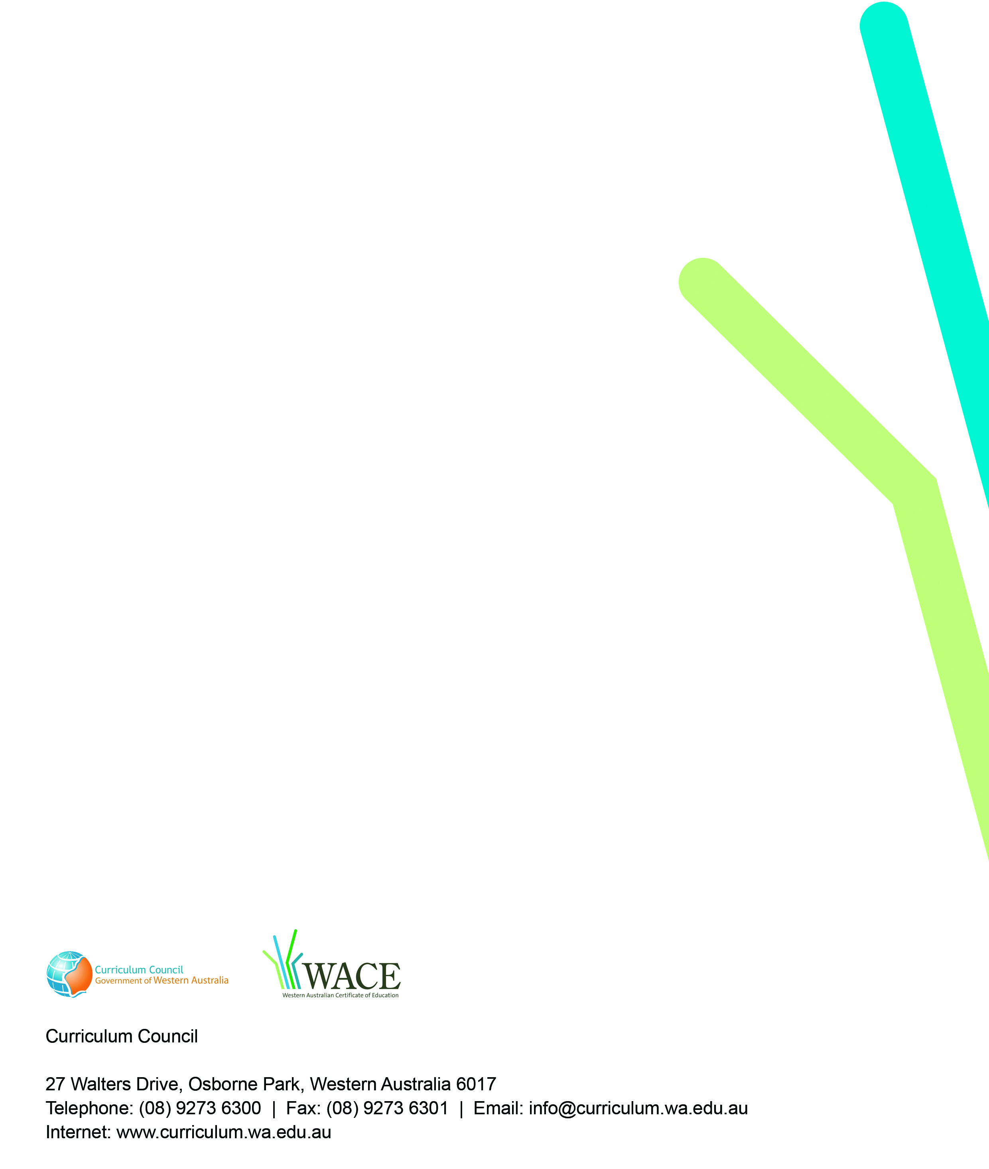
2009/8129[v3]

